
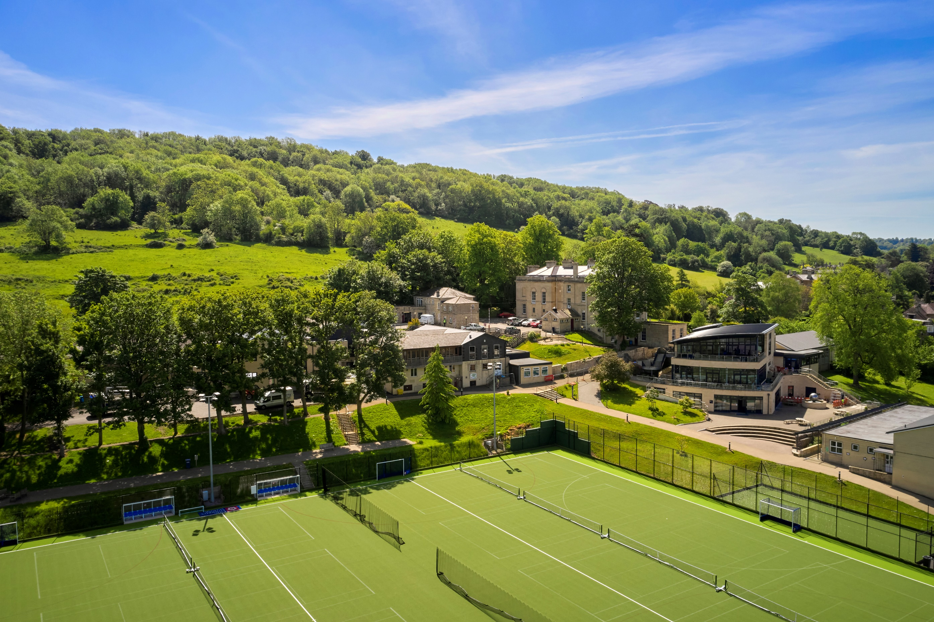



HEAD OF
SPANISH
THE SCHOOL FOR ADVENTUROUS MINDS
INFORMATION FOR CANDIDATES
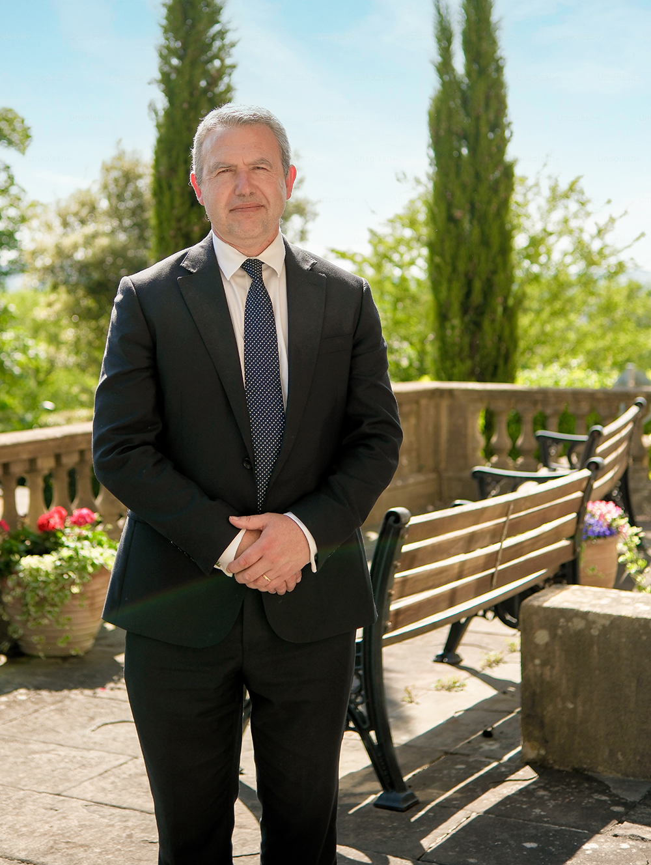
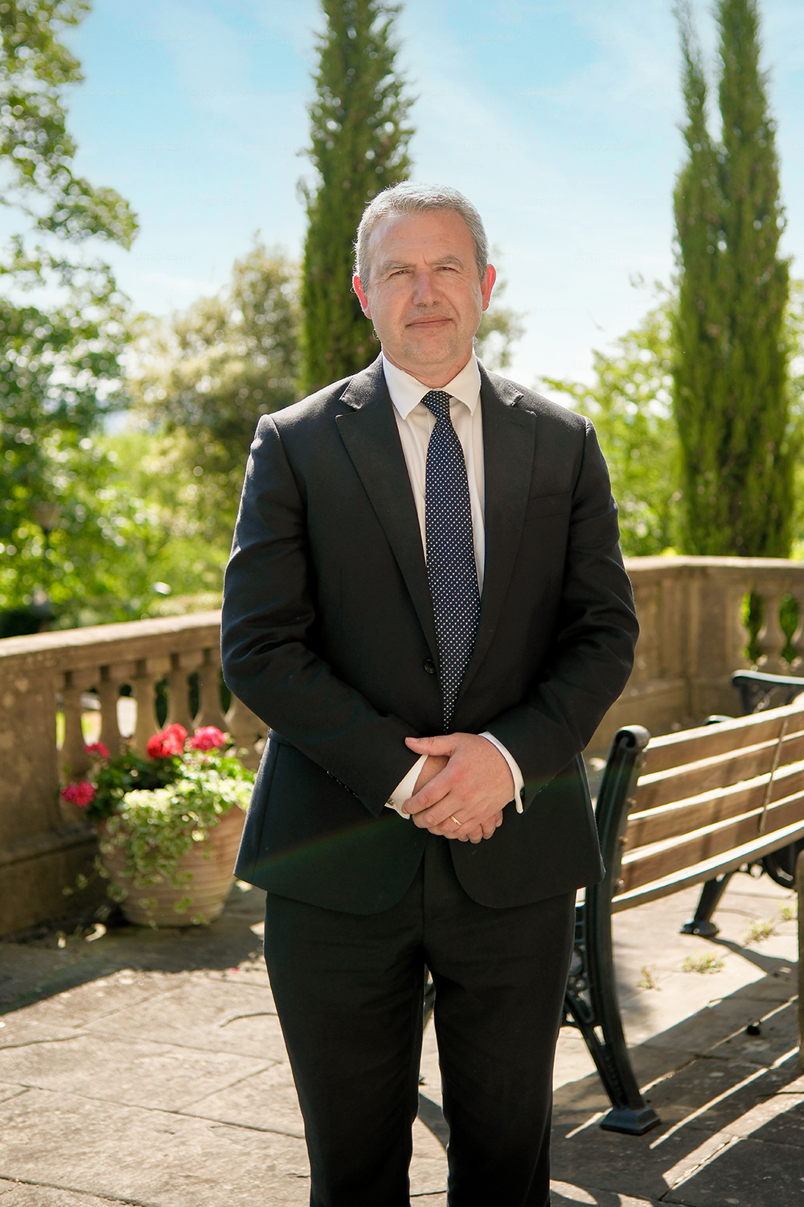
Applications are invited for the post of
 HEAD OF SPANISH
Permanent, Full Time or Part Time (0.8)
From April or September 2027
Thank you for your interest in our permanent, full time or part time (0.8) role of Head of Spanish at King Edward’s School, Bath. This is an exciting opportunity for a suitably qualified Spanish teacher to lead a successful and thriving department.
Founded in 1552, King Edward’s School, Bath has held a special place in the city for well over four and a half centuries and is now firmly established as one of the leading schools in the South-West of England, being recognised recently as the Sunday Times Independent Secondary School of the Year in the South-West for 2026. As an all-through school, the Pre-Prep, Junior and Senior sections of King Edward's offer an inspiring and supportive environment for children aged 3 to 18. All pupils are encouraged to be the best they can be, and all are nurtured along the pathway to leading happy, fulfilled and successful lives at School and beyond.
King Edward’s School is committed to safeguarding and promoting the welfare of children and young people, and applicants must be willing to undergo safeguarding screening, which includes successful clearance of an enhanced DBS check, receipt of satisfactory references and a pre-employment health questionnaire. We are an inclusive school and welcome applications from people of all beliefs and backgrounds.
With highly motivated and academically ambitious pupils, this role is a chance to champion and promote the teaching of Spanish, support academic excellence and cultivate independent learning in a well-resourced environment. If you have a passion for teaching, a love of the languages and a desire to make a real impact on young lives, we hope that you will consider making an application.
Yours sincerely,
Martin Boden
Headmaster


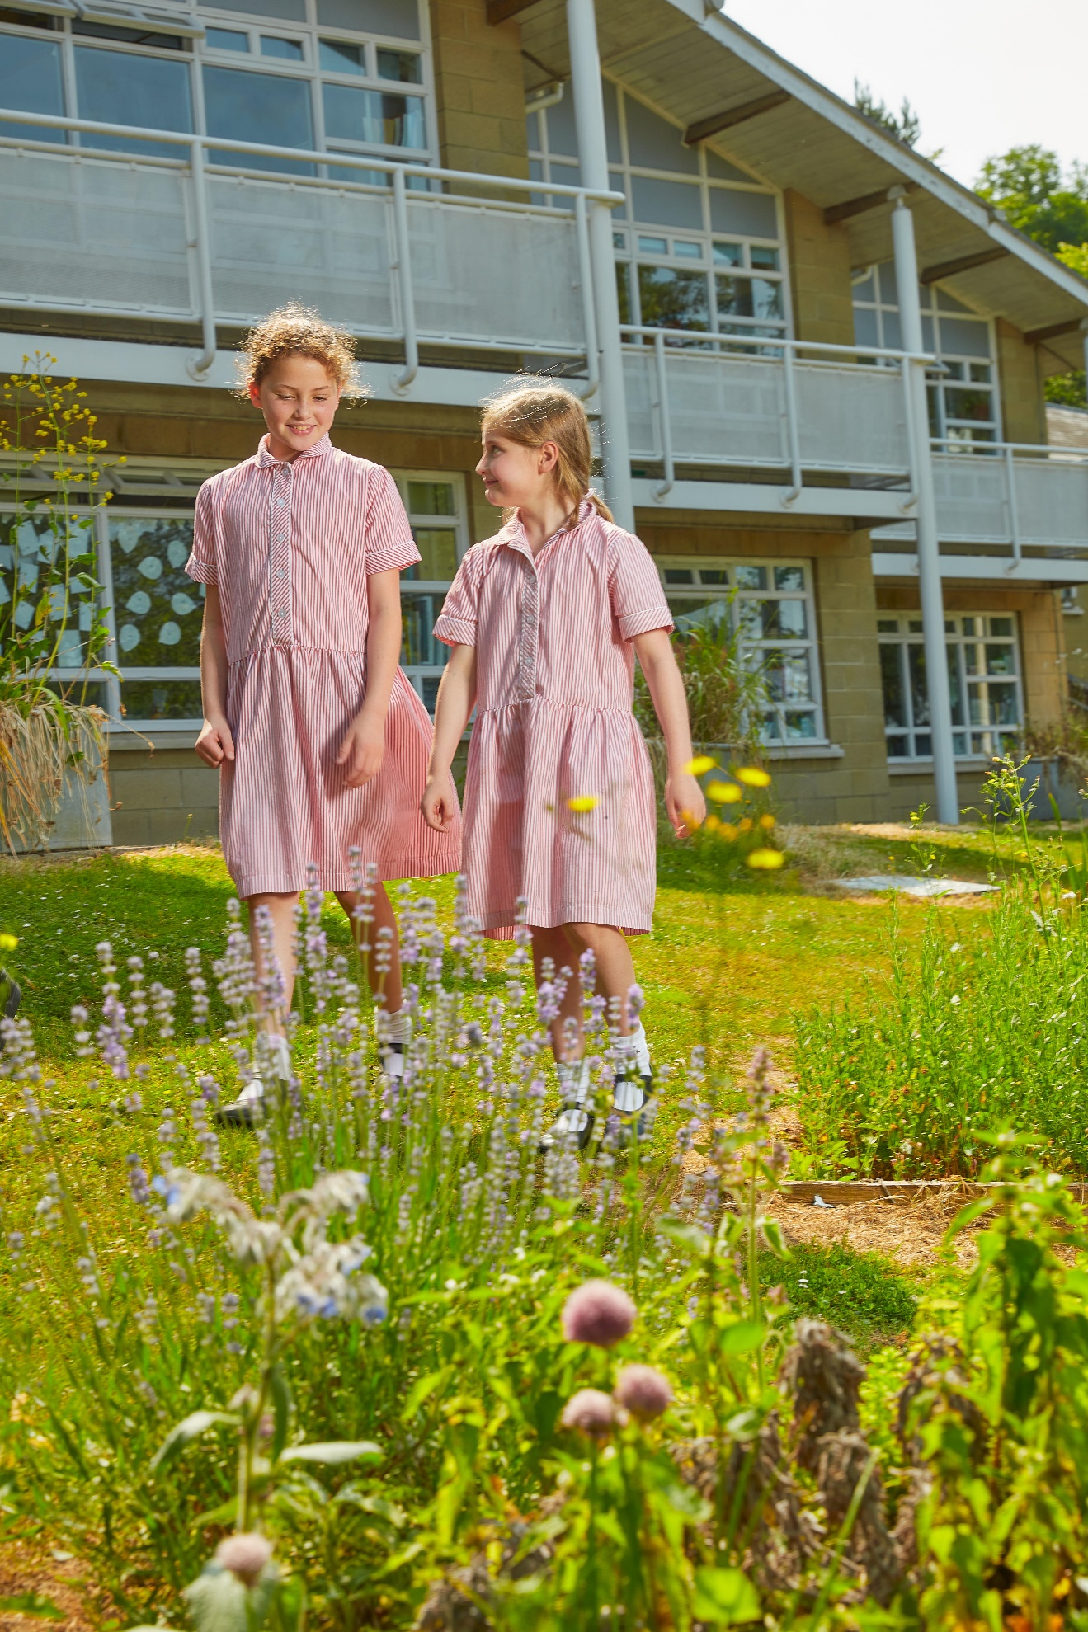
SCHOOL BENEFITS
- Supportive CPD which can include access to further qualifications and training.
- Generous and competitive school fee remission.
- Free refreshments, fruit and a 3-course lunch during term time.
- Employee assistance packages - Aviva SmartHealth and L&G Sparks.
- Recently refurbished gym on-site and access to gym membership offer for the University of Bath.
- Tax-efficient Cycle to Work Scheme.
- Pilates classes for staff, with colleagues also welcome to join the Senior School's weekly lunchtime Running Club.
- Support towards prescription glasses and eye tests.
STAFF PENSION
If eligible, you will be automatically enrolled into King Edward’s School, Bath Group Personal Pension Plan (“the DC Plan”) with an employer’s maximum contribution of 20% of salary, to be matched by a 10% employee contribution.
We are confident that you will find working at KES inspiring, but don’t take our word for it – read what some of our staff say about working at KES by visiting our website:
We Are KES Bath | About | King Edward's School, Bath

THE POST
Applications are invited from energetic and well-qualified university graduates or teachers seeking to be part of a dynamic, well-resourced and very successful Spanish Department which teaches the subject from Year 7 to A-Level.
The successful candidate will be able to teach across the whole range of age and ability, including A-Level Spanish.
The post would suit an experienced teacher with a proven record of successful results; relevant leadership experience is desirable but not essential.
A willingness to make a wider contribution to the pastoral, extra-curricular and co-curricular life of the School is expected.
“
KES PUPILS ARE GENUINELY INTERESTED TO LEARN AND THIS, COMBINED WITH A TEACHING STAFF WHO PUSH THEMSELVES TO DELIVER TOP NOTCH LESSONS, MEANS THAT OUTCOMES ARE EXCELLENT.”
THE GOOD SCHOOLS GUIDE
 THE MODERN LANGUAGES FACULTY
There are currently ten members of the faculty, across three languages: French, German, and Spanish. All are experienced and enthusiastic dual linguists. As a department, we seek to encourage and serve the entire ability range at King Edward’s. We employ a variety of teaching methods based on a communicative approach which nonetheless prepares pupils for the academic rigour of advanced courses. We are a thriving and dedicated department. Languages are popular with our pupils, and the Department achieves excellent results.
French, German, and Spanish are taught from Year 7 up to A-Level. In Years 7 and 8, all pupils study two modern languages, selected from French, German, and Spanish. In Year 9, many pupils continue with both of their chosen languages. In Years 7 to 9, there are three lessons per fortnight for each of these languages (all lessons are one hour in length). Pupils are required to take one modern language to GCSE, and some take the option of two. All KS4 pupils receive extra conversation practice with native speakers at lunchtimes or in lessons. There are usually two or three groups in each of the GCSE year groups for all of our languages. At A-level, each subject has one set in each year group, and at times two for French and Spanish. Year 12 pupils have 9 lessons per fortnight and Year 13 pupils 10 lessons, plus a weekly conversation class in small groups. At GCSE, the Department follows the Edexcel IGCSE syllabus. At A-Level, French, German, and Spanish follow the Eduqas A-Level syllabus.
The Department has four large teaching rooms, one per language plus a general languages room, and a smaller teaching room for Years 12 and 13. In addition, we have a language laboratory with 25 computers. All of these rooms have a permanent sound system and a modern wall-mounted interactive screen. The languages departments share a large office on the ground floor.
The languages departments are extremely well resourced. French is taught with the support of Dynamo textbooks at KS3 and Studio at KS4, German follows the Echt textbooks in Years 7 and 8, and the AQA GCSE German textbooks (Foundation in Year 9 and Higher in Years 10 and 11), and Spanish is taught with support from Viva at KS4. There is much additional material for reading and listening. The Sixth Form have multiple online subscriptions to language-learning platforms. All languages use grammar and translation books for revision and extension material. We have large banks of additional topic material in the school’s Virtual Learning Environment and on our internal SharePoint drive.
Immersion trips are run biennially by the Department, with an exchange still taking place every year in the German Department. The Spanish immersion trip to Málaga is always well attended. The Department also supports popular trips to France, Germany and Spain as part of the Activities Week programme, although these are not exclusively language trips and are open to pupils not studying the language. In addition, we regularly take students to Bath or Bristol for theatrical productions and visits to the cinema to see foreign language films.

THE SPANISH DEPARTMENT
The successful candidate will join a department of committed, enthusiastic teachers who are passionate about the importance of language learning. There are currently three members of staff who teach Spanish as their main language. The Department recruits very well for GCSE and A-Level and is a popular language within the School. There are currently six GCSE and two A-Level groups. The Department is based on the ground floor of L block.
Last summer, 57 pupils took the Spanish IGCSE and 46% achieved a Grade 9, with 97% achieving a Grade 7 or above. At A-level, 100% of pupils achieved A*-B grades.
Each year, several pupils choose to continue language studies at university, either as a discrete subject or studied alongside subjects such as History or Economics. The successful applicant will help to maintain and develop this tradition. Several pupils have recently gained Oxbridge places for languages.



JOB SPECIFICATION
RESPONSIBLE TO:
The Head of Modern Foreign Languages who has overall responsibility for the Modern Languages Faculty.
RESPONSIBLE FOR:
The fundamental expectation of a teacher at King Edward’s School is that they should contribute wholeheartedly and positively to the life and work of the School. Each teacher is directly responsible for the positive, efficient and professional running of their classes, in line with agreed departmental policy; this will include following departmental schemes of work and assessment policies. Each teacher is also responsible for the good behaviour of classes and the care of departmental resources and the classroom in which they teach. Teachers at King Edward’s, including those who are part-time value the importance of contributing to the School as a whole and recognise that some aspects of their duties might fall on a day when they are not timetabled for lessons (e.g. Open Day, Entrance Exams, Parents’ Evenings, INSET/CPD).
All members of staff share a corporate responsibility for the welfare, good order and discipline of pupils in all school activities. It is also the responsibility of all staff to be aware of and uphold School policies, especially those relating to safeguarding, and to work to uphold budgets and sound financial control.
As part of their responsibility towards supporting the pastoral life of the School, teachers are required to carry out a pastoral role within the school as a Form Tutor, Co-Tutor or Associate Tutor.
Teachers at King Edward’s School will also contribute to the co-curricular life of the School. Such contributions may take many different forms, as the School values the diverse talents and enthusiasm of staff, and could include taking a sports team (for non-PE staff), running a weekly club, being involved in significant weekend commitments such as the Duke of Edinburgh’s Award, Ten Tors or Model United Nations and termly sports fixtures. The nature of such a commitment and the time involved will need to meet the needs of the school and be approved by the Headmaster.
“
THE TEAM I WORK IN IS LIKE A FAMILY, WE ALL COLLABORATE AND HELP EACH OTHER, AND I FEEL PROUD TO TELL PEOPLE THAT I WORK IN A SCHOOL WITH A GREAT REPUTATION AND THAT IS SO SUPPORTIVE.
KATIE BARNSLEY
DEPUTY HEAD TEACHER PRE-PREP & NURSERY
Teachers are expected to follow the Teachers’ Standards set by the Department for Education:
The Head of Spanish will provide academic, organisational and strategic leadership for Spanish within the Modern Languages Faculty, while fulfilling all the professional and teaching responsibilities set out below. The postholder will be willing and able to teach Spanish at all levels throughout the School, including Oxbridge or equivalent preparation; will remain conversant with recent scholarship and developments in language teaching; and will inspire pupils across the ability range. A dynamic approach to teaching and departmental leadership must be allied to excellent organisation and a clear grasp of the requirements of examination board specifications. The Head of Spanish will work closely with the Head of Modern Languages and the Deputy Head (Academic).
- Setting high expectations which inspire, motivate and challenge pupils.
- Promoting good progress and outcomes by pupils.
- Demonstrating strong subject and curriculum knowledge.
- Planning and teaching well-structured lessons.
- Adapting teaching to respond to the strengths and needs of all pupils.
- Making accurate and productive use of assessment.
- Managing behaviour effectively to ensure a good and safe learning environment.
- Fulfilling wider professional responsibilities.
- Demonstrating consistently high standards of personal and professional conduct.
- Delivering high-quality teaching to the classes and pupils allocated in the timetable.
- Planning, preparing and delivering courses and lessons in line with agreed school and department policies, seeking and offering advice and support, as appropriate, from and to departmental colleagues and the Head of Department.
- Preparing pupils for public and internal examinations, including maintaining a thorough and up-to-date knowledge of current examination specifications, regulations and policies.
- Setting and marking work regularly according to school and department policy, including formal assessments and internal exams, which is appropriate to the needs and abilities of the pupils.
- Keeping suitable records of each pupil’s attendance, behaviour and performance which will enable proper assessment, tracking and timely reporting (to both pupils and parents). In so doing, the teacher should be mindful of the need to support, motivate and encourage each pupil.
- Writing academic checks, reports, UCAS references and other similar material.
- Attending Parents’ Evenings and meeting with parents, as required.
- Making timely contact with parents over academic issues relating to the progress of a pupil, as well as responding to concerns and queries from parents.
- Supporting the work of the Head of Department and contributing to the work of the department in developing new courses, materials and methods.
- Contributing to departmental meetings organised by the Head of Department.
- Maintaining a thorough and up-to-date subject knowledge and taking account of wider curriculum and pastoral developments which are relevant to the work of a teacher.
- Maintaining a high standard of professionalism through appropriate dress, behaviour, conduct and communication with pupils, parents, colleagues and members of the public, as a loyal ambassador for the School.
- Actively participating in CPD/INSET and taking responsibility for their own professional development to improve teaching and students’ learning.
- Actively participating in the School’s system of professional review and being reviewed by line managers and a member of the review team.
- Fulfilling other duties expected of each teacher from time to time, such as supervisory duties during lunch and break, examination invigilation and cover for absent colleagues.
- Supporting and attending assemblies, Prizegiving, Open Evening and Open Day, Founder’s Day and other events, as required.
- Promoting the general progress and well-being of individual pupils.
- Working closely with pastoral staff over the teaching and learning of pupils and keeping pastoral staff informed of academic issues, potential learning support issues and behavioural concerns.
- Maintaining good order and discipline among pupils, both within and without the School, enforcing fairly but unequivocally the School’s code of conduct and rules.
- Ensuring that pupils respect school property.
- Upholding the ethos, purpose and values of the School.
- Developing a good understanding of policies and procedures within the School and, when required, contributing to policy review and development, in line with the School’s Development Plan.

Head of Spanish:
Leadership and Management Responsibilities
Teaching and Learning
- Establishing and promoting the educational aims of Spanish within the wider aims of the Modern Languages Faculty and the School.
- Providing colleagues with clear guidance on appropriate and effective teaching styles and methodologies, and ensuring that subject knowledge and pedagogical practice remain current and are shared within the department.
- Setting, reviewing and developing schemes of work, curriculum plans, marking and assessment procedures, including the tracking and monitoring of pupils’ progress in liaison with relevant senior colleagues.
- Ensuring that pupils at all levels are challenged, supported and inspired, and overseeing the department’s provision for pupils with SEND and other learning needs.
- Liaising with pastoral staff about the academic and pastoral welfare and progress of pupils, where this relates to Spanish.
- Providing subject enrichment through clubs, competitions, trips and exchanges (MFL roles require the willingness to lead and accompany trips abroad with the expectation that a meaningful trip to a Spanish speaking country will be organised at least every two years, possibly annually), as well as other activities, as appropriate; supporting the effective use of digital technology within teaching and learning.
- Overseeing the quality and consistency of departmental reports, academic checks and UCAS references.
Administration and Communication
- Maintaining thorough knowledge of current examination specifications and requirements, making appropriate use of INSET and communicating relevant information to colleagues, pupils and parents.
- Holding regular departmental meetings with published agendas and minutes where appropriate, and ensuring effective communication between the Spanish Department, the Head of Modern Languages, the Deputy Head (Academic) and other senior colleagues.
- Submitting an annual review of departmental performance in public examinations and using performance evidence to inform priorities for improvement.
- Maintaining an up-to-date departmental handbook, an appropriate overview of health and safety, and an annually reviewed departmental development plan.
- Maintaining effective and timely communication with parents on departmental matters.
Departmental Management and Staff Leadership
- Leading, inspiring and line-managing departmental teaching staff, promoting high standards, collaboration and staff welfare.
- Supporting colleagues’ professional development through appropriate INSET, coaching and objectives established within the School’s professional review arrangements.
- Contributing to the recruitment, selection, induction and review of departmental staff and acting as a subject mentor for ECTs or trainee teachers where required.
“
- Advising on the allocation of departmental staff to teaching groups in consultation with relevant senior colleagues.
- Representing Spanish at Heads of Department and faculty meetings and at other meetings or functions as requested, including GCSE and A Level Choices events.
- Working constructively with the Heads of French and German and the Head of Modern Languages, contributing to cross-phase and whole-school development, liaising with other schools where appropriate, and upholding all School policies.
- Overseeing the display and celebration of pupils’ work in departmental and public areas.
Resources, Promotion and Pupil Recruitment
- Ensuring that accommodation, resources and equipment remain appropriate to departmental aims and pupils’ needs, within agreed budgetary constraints.
- Managing the Spanish departmental budget in liaison with the Head of Modern Languages, Deputy Head (Academic) and Bursar, as appropriate.
- Promoting Spanish through School publications, the website and other appropriate channels.
- Coordinating the department’s displays, promotion and staffing for Open Evening, Open Day and other recruitment events, and interviewing prospective pupils where required.
- Duties may be delegated to colleagues following appropriate consultation and mutual agreement; the Head of Spanish retains responsibility for their satisfactory completion.
The Head of Spanish may also be required to undertake any other duties as reasonably directed by the Headmaster or deputies.
KES IS IN THE HEART OF THE CITY AND HAS A BEAT LIKE NO OTHER! I HAVE BEEN TEACHING HERE FOR 24 YEARS AND THE JOY OF THE SCHOOL IS THE PUPILS WHO MAKE IT A SCHOOL AND THE TEACHERS WHO NURTURE TO HELP THE SEEDS TO GROW.
D WILLISON
ART TEACHER
QUALIFICATIONS | ESSENTIAL | DESIRABLE
Degree level qualification in a discipline related to the subject | 🗸
Relevant additional subject specific qualifications |  | 🗸
Qualifications related to teaching including QTS and any relevant PGCE | 🗸
PERSON SPECIFICATION

KNOWLEDGE AND EXPERIENCE | ESSENTIAL | DESIRABLE
Deep understanding of topics covered in the subject | 🗸
Familiarity with the curriculum and exam board specifications | 🗸
Understanding of how pupils learn and develop, which can help in creating effective teaching strategies | 🗸
Skills in managing a classroom and engaging pupils in the subject matter | 🗸
Ability to assess and provide feedback on pupil work effectively | 🗸
Providing support and guidance to pupils, helping them with both academic and personal challenges | 🗸
Proven record of successful teaching of Spanish, including at GCSE and A-level, with the capacity to prepare pupils for highly selective university courses. | 🗸
Experience of leading colleagues, curriculum development, assessment and departmental improvement |  | 🗸
Experience of line management, staff development, departmental budgeting and the organisation of enrichment or overseas visits |  | 🗸
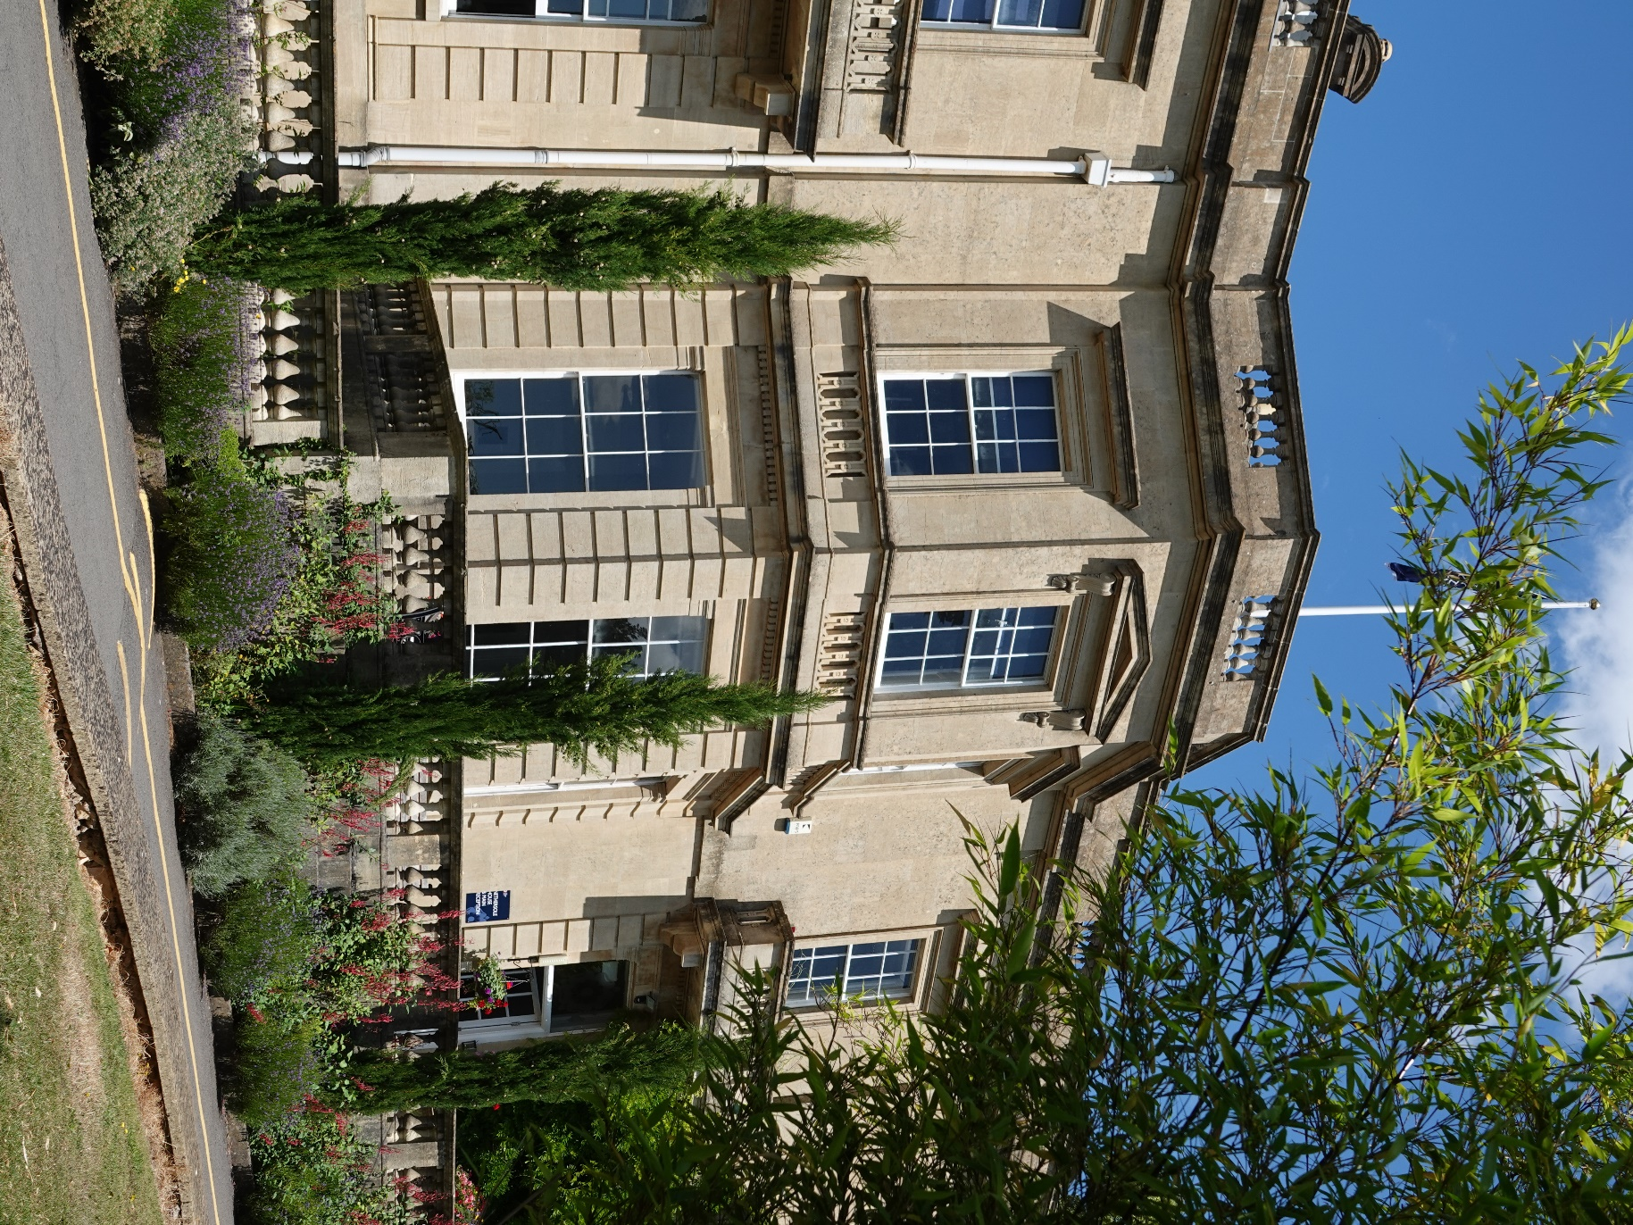
PERSONAL QUALITIES | ESSENTIAL | DESIRABLE
Genuine enthusiasm for the subject to inspire and engage pupils of all ages. | 🗸
Ability to remain calm and patient, especially when pupils struggle with complex concepts | 🗸
Excellent verbal and written communication and interpersonal skills | 🗸
Flexibility to adjust teaching methods to suit different learning styles and needs | 🗸
Innovative approaches to teaching that make learning interesting and enjoyable | 🗸
Dedication to pupils' success and continuous improvement in teaching practices | 🗸
Ability to lead and inspire a highly capable team, combining clear expectations with a collaborative and supportive approach | 🗸
Excellent strategic, organisational and communication skills, with the judgement to prioritise, delegate appropriately and remain accountable | 🗸
Strong organisational skills to manage lesson plans, marking, and administrative tasks efficiently. | 🗸
Ability to handle the challenges and pressures of teaching with a positive attitude | 🗸
SALARY
Salaries at the School are based on our own KES Salary Scale and will take into account the qualifications and experience of the successful candidate.
The KES Salary Scale is enhanced above the National State Qualified Teachers’ Scale, ranging from £35,372 to £56,951 at a teacher level and beyond this for those with managerial responsibilities.
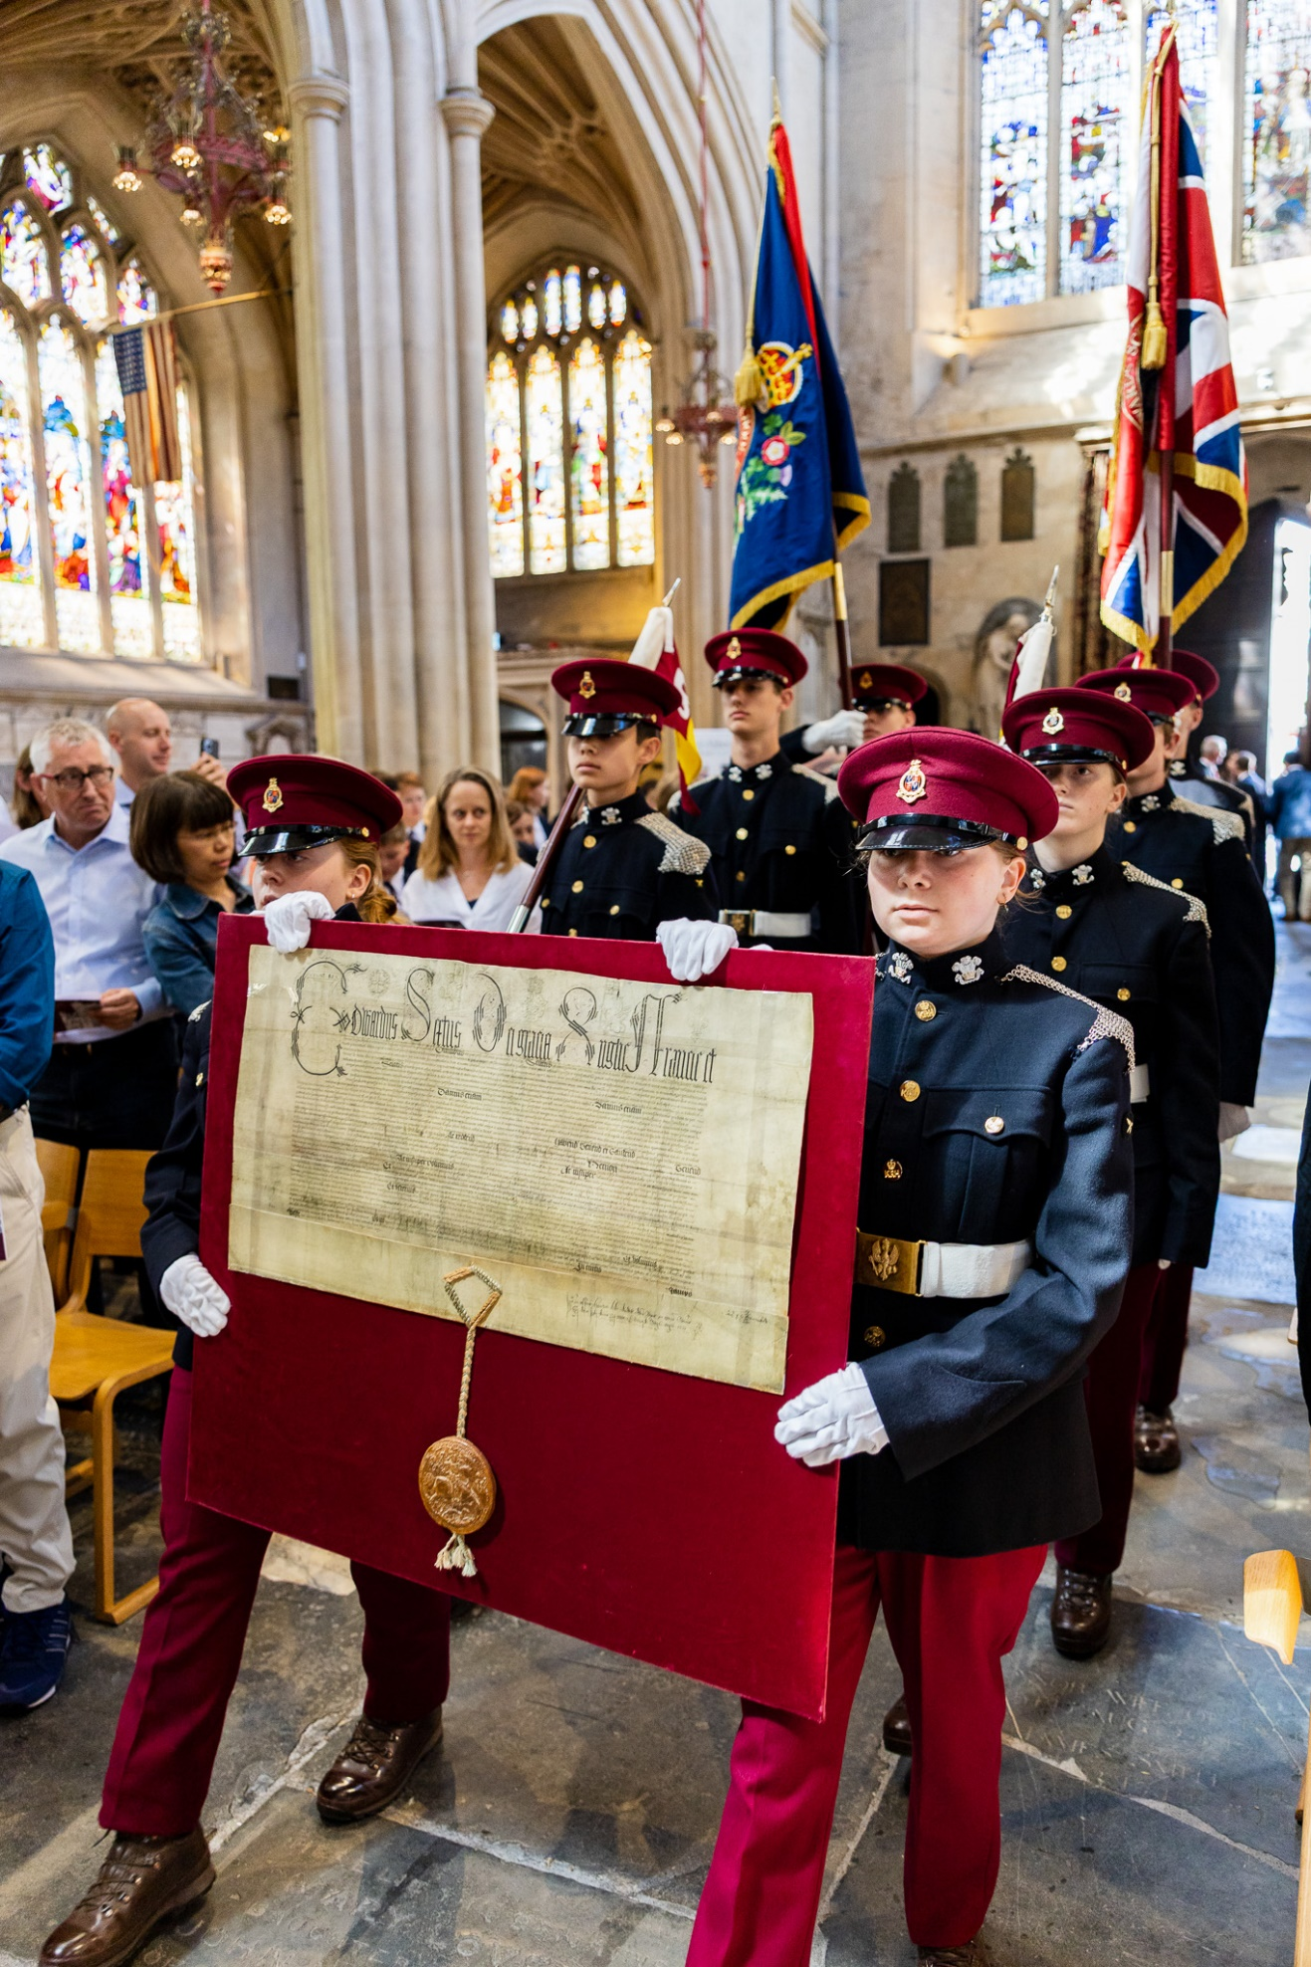
All staff are in a position of trust and have a duty to keep children and young people safe and to protect them from neglect and physical and emotional harm. This duty is in part exercised through the development of respectful caring and professional relationships between staff, children, and young people. Staff are expected to be familiar with the local child protection arrangements and understand their responsibilities in order to safeguard and protect children and young people.
King Edward’s School is committed to safeguarding and promoting the welfare of children and young people and applicants must be willing to undergo safeguarding screening including checks with past employers and a DBS disclosure in accordance with the DBS Code of Conduct. All appointments are made subject to satisfactory DBS clearance. All prospective candidates must have the right to work in the UK for the entire duration of the proposed term. The suitability of all prospective employees or volunteers will be assessed during the recruitment process in line with this commitment.

APPLICATION PROCEDURE
Further details and an application form can be obtained from the School’s website or from the School’s HR Department at recruitment@kesbath.com.
Applications should be made via the School’s website where applicants can summarise their suitability for the post, including their relevant experience.
These should be received by end of the day Tuesday 17 November; however, early application is encouraged as we may look to invite strong candidates for earlier interview.
Interviews are likely to be held on Thursday 26 November.
Please note that we are unable to give feedback to applicants not invited for interview.

KES PUPILS ARE GENUINELY INTERESTED TO LEARN AND THIS, COMBINED WITH A TEACHING STAFF WHO PUSH THEMSELVES TO DELIVER TOP NOTCH LESSONS, MEANS THAT OUTCOMES ARE EXCELLENT.”
THE GOOD SCHOOLS GUIDE
“


OUR PURPOSE & VALUES

