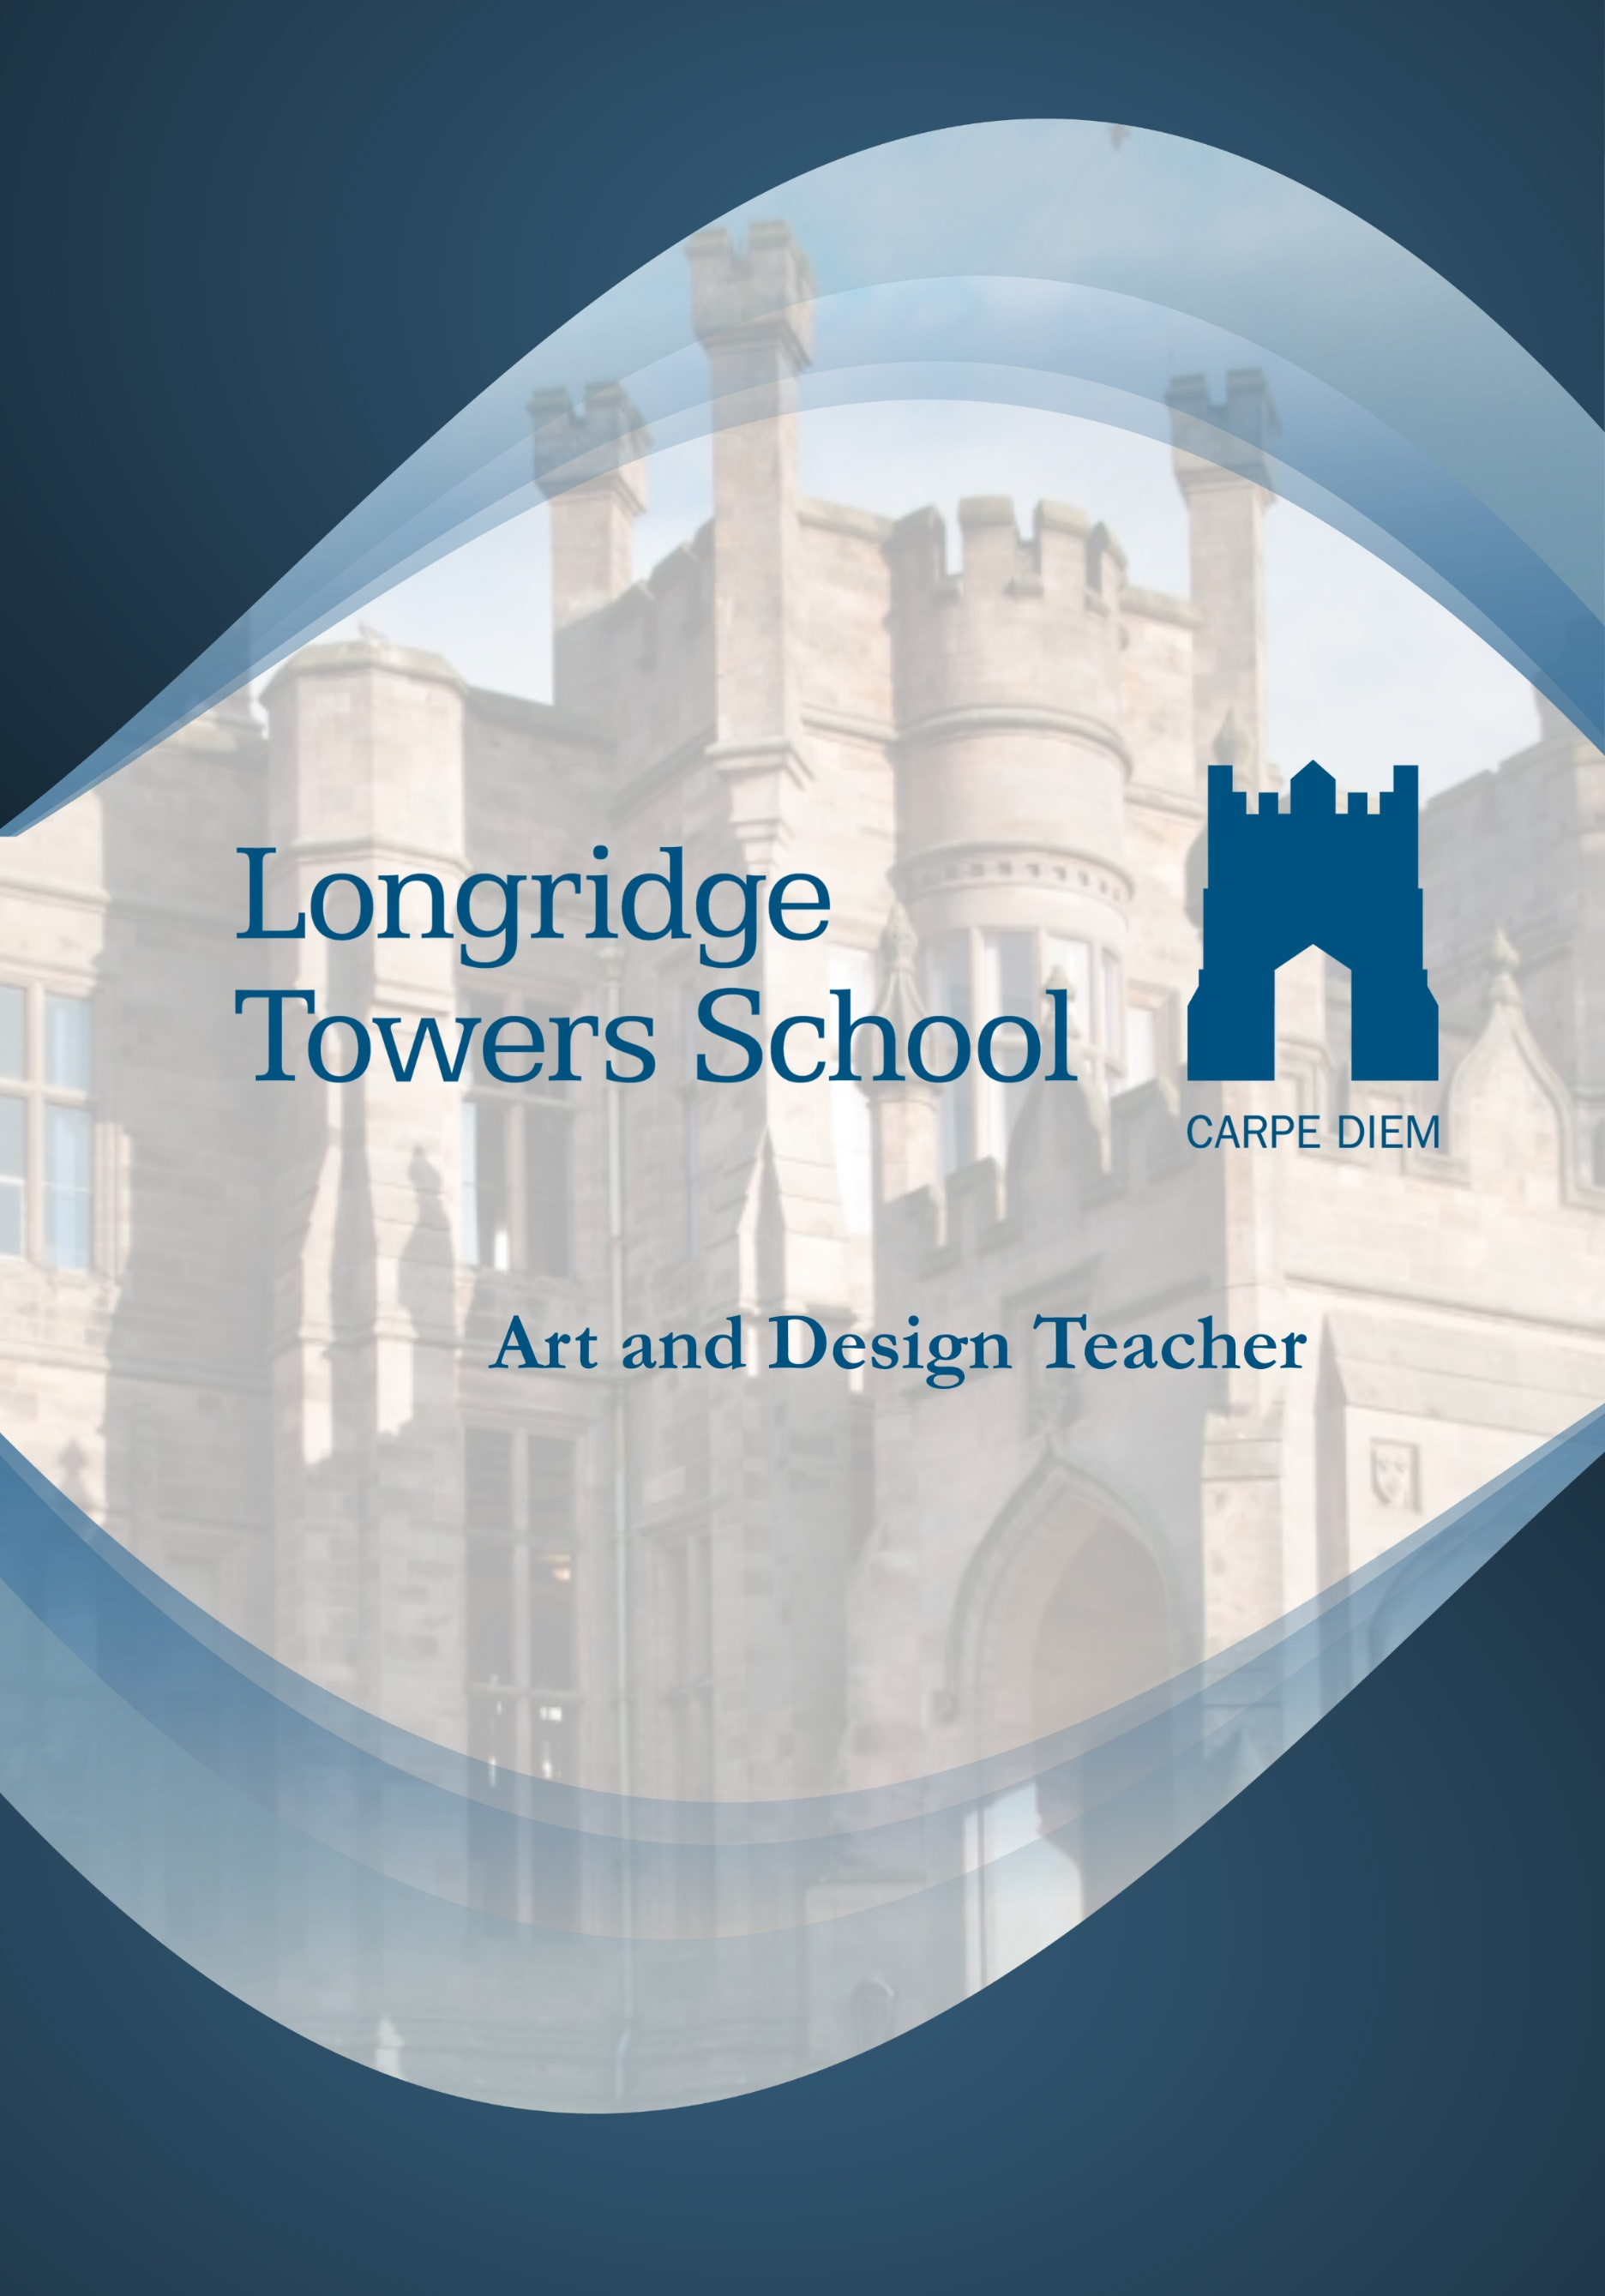

Job Description

ART AND DESIGN TEACHER

Responsible to: Deputy Head

Main Purpose of the Role

The Art and Design Teacher at Longridge Towers School plays a vital role in delivering a rich, creative, and inspiring learning experience in art to pupils aged 3 to 19 within an all-through school setting. This position supports the School’s vision of fostering a vibrant, friendly community with high aspirations for pupils and staff alike. The teacher will nurture pupils’ enjoyment and understanding of art, encouraging creativity and critical thinking through innovative and engaging teaching practises. The role requires setting high expectations for all pupils, including those with SEND, ensuring that every pupil develops their artistic skills and achieves their full potential in line with the school’s ethos.

This job description should be seen as enabling rather than prescriptive and may be reviewed annually by the post holder and the Head Teacher.

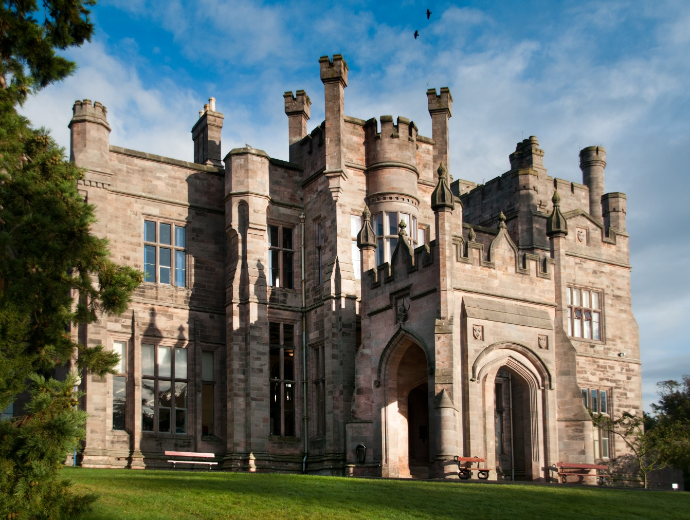

Teaching and Learning
- Deliver high-quality, engaging lessons in Art & Design for across Juniors, KS3, GCSE, and A Level.
- Plan, prepare, and assess lessons using differentiated strategies to meet all pupils’ needs.
- Encourage creativity, critical thinking, and artistic exploration in pupils.
- Organize educational visits, projects, and exhibitions to enrich learning experiences.
- Maintain accurate records of pupils’ progress and provide constructive feedback.

Pastoral and School Community
- Support school policies and contribute to a positive, inclusive school culture.
- Act as a Form Tutor when required, supporting pupils’ personal and academic development.
- Participate in extra-curricular activities, clubs, and school events to enhance pupil engagement.
- Display pupils’ work to celebrate achievements and boost confidence.
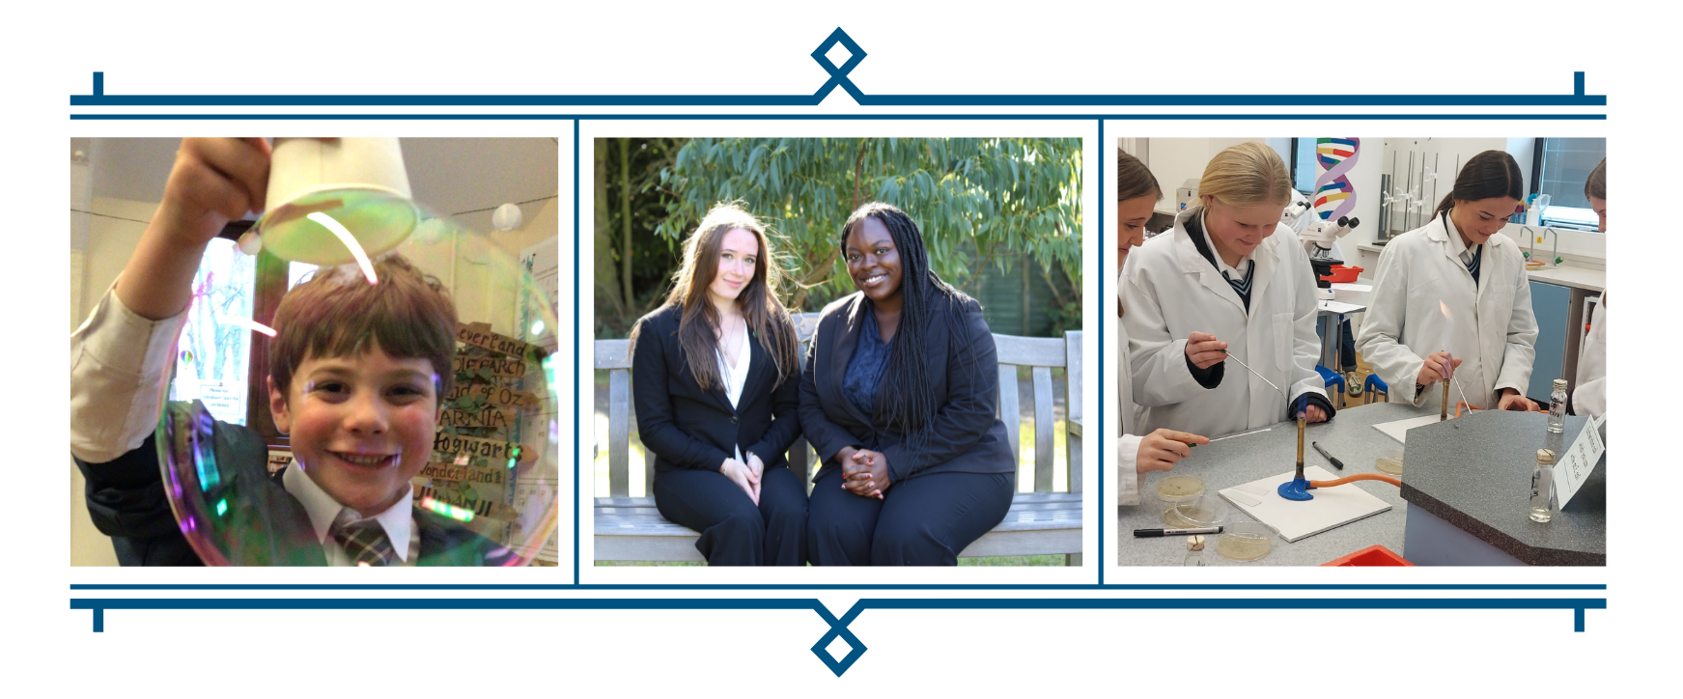

Professional Development
- Stay current with developments in art education and innovative teaching methods.
- Engage in professional learning, appraisals, and collaborative curriculum development.
- Contribute to the development of teaching resources, assessment methods, and school initiatives.

Administration
- Maintain accurate records and reports of pupil progress.
- Communicate effectively with parents, colleagues, and leadership teams.
- Support the smooth running of the department and school as required.
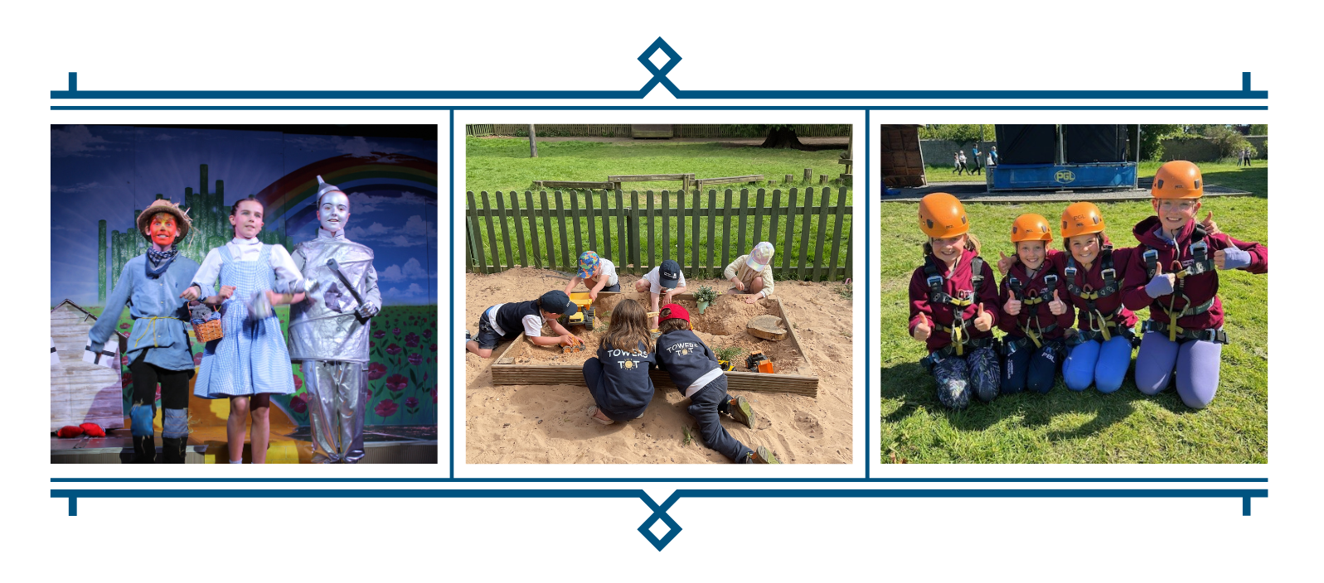

Skills & Experience
Essential
- Qualified Teacher Status (QTS) or equivalent.
- Strong knowledge of Art & Design and current teaching practices.
- Passion for inspiring creativity and supporting pupils’ artistic development.
- Excellent classroom management and organizational skills.
Desirable
- Experience with digital media and contemporary art practices.
- Experience leading extra-curricular programs or school exhibitions.
- Experience working with diverse learner needs, including SEND pupils.

Whilst every effort has been made to explain the main duties and responsibilities of the post, it is impossible to identify every individual task which coordinators undertake. The School hopes that Class Teachers will assist with any reasonable request to undertake work of a similar level that is not specified in this job description. This job description may be amended at any time following discussion between the Head and members of staff.
